“Understanding the Political Structure and Administrative Areas of the Nation”
Worksheet

Theme: Hong Kong under “One Country, Two Systems”
Topic: Situation of the country and sense of national identity

Search on the web for a piece of news article about the function(s) of the State Council of the People’s Republic of China. Stick the news clipping in the space below and briefly introduce the contents of the news article, and the main function(s) of the State Council.

Title of the news article: ____________________________________________________
Source of information: __________________________________
Issuing date: ____________(year) _______(month) _______(day)

The main point(s) of the article:

The main function(s) of the State Council is/are:

Example of information search
Title of the news article: Li urges action on key tasks
Source of information: China Daily
（http://www.chinadailyhk.com/article/160589）
Issuing date: 16/3/2021
The main point(s) of the article: In the State Council’s executive meeting, Premier Li Keqiang urges that all key tasks laid out in the Government Work Report must be effectively implemented to sustain steady economic and social development.
The main function(s) of the State Council is/are:
Stipulating administrative measures, formulating administrative regulations and issuing decisions and orders in accordance with the Constitution and the law.

Study Source A, and answer the questions.

Source A
- According to Article 57 of the Constitution of the People’s Republic of China (hereafter referred to as the Constitution), the National People’s Congress (hereafter referred to as NPC) is the highest state organ of power. The NPC shall be composed of deputies elected from the provinces, autonomous regions, cities directly under central government jurisdiction, special administrative regions and armed forces. Each NPC shall have a term of five years. According to Articles 62 and 63 of the Constitution, the NPC shall exercise the following functions and powers:
  - To supervise the enforcement of the Constitution, to enact and amend criminal, civil, state institutional and other basic laws.
  - To elect the president and the vice president of the People’s Republic of China, the chairperson of the Central Military Commission, the president of the Supreme People’s Court, the procurator general of the Supreme People’s Procuratorate, and to decide, based on nomination by the president of the People’s Republic of China, on the successful candidate for the premier of the State Council, and have the power to remove the above personnel from office.
- To examine and approve the plan for national economic and social development and the report on its implementation; to examine and approve the state budget and the report on its implementation.

- According to Article 21 of the Basic Law, Chinese citizens who are residents of the Hong Kong Special Administrative Region shall be entitled to participate in the management of state affairs according to law. In accordance with the assigned number of seats and the selection method specified by the NPC, the Chinese citizens among the residents of the Hong Kong Special Administrative Region shall locally elect deputies of the Region to the National People's Congress to participate in the work of the highest state organ of power.

Excerpted from the following sources:
- “State Structure and Key State Organs of the People’s Republic of China”, Liberal Studies Curriculum Resources Booklet Series: Modern China, p.65-70
- The Constitution of the PRC and the Basic Law of the HKSAR of the PRC. Retrieved from https://www.basiclaw.gov.hk/en/basiclawtext/index.html
Knowledge-based Questions

- What are the main functions and powers of the following institutions of the nation? Please appropriately match the institutions of the nation in Column A with the relevant functions and powers / descriptions in Column B (You can match each item with more than one items).

Column A  Institutions of the nation |  | Column B  Main functions and powers of institutions of the nation / descriptions
The National People’s Congress • |  | • [A] | The highest adjudicatory organ of the nation
The National People’s Congress •  Standing Committee |  | • [B] | To engage in affairs of state on behalf of the nation
The President of the People’s •  Republic of China |  | • [C] | The highest state organ of power
The State Council of the People’s •  Republic of China |  | • [D] | To exercise the legislative power of the state
The Central Military Commission •  of the People’s Republic of China |  | • [E] | The permanent organ of the National People’s Congress
The National Commission of •  Supervision of the People’s  Republic of China |  | • [F] | The highest procuratorial organ of the nation
The Supreme People’s Court • |  | • [G] | The highest state administrative organ
The Supreme People’s Procuratorate • |  | • [H] | To lead the country’s armed forces
 |  | • [I] | The highest supervisory organ of the nation
Suggested answer
Column A  Institutions of the nation | Column B  The main functions and powers of institutions of the nation / descriptions
The National People’s Congress | [C] | The highest state organ of power
The National People’s Congress | [D] | To exercise the legislative power of the state
The National People’s Congress  Standing Committee | [E] | The permanent organ of the National People’s Congress
The National People’s Congress  Standing Committee | [D] | To exercise the legislative power of the state
The President of the People’s  Republic of China | [B] | To engage in affairs of state on behalf of the nation
The State Council of the People’s Republic of China | [G] | The highest state administrative organ
The Central Military  Commission of the People’s Republic of China | [H] | To lead the country’s armed forces
The National Commission of Supervision of the People’s  Republic of China | [I] | The highest supervisory organ of the nation
The Supreme People’s Court | [A] | The highest adjudicatory organ of the nation
The Supreme People’s Procuratorate | [F] | The highest procuratorial organ of the nation

2. Which of the following are the main functions and powers of the State Council of the People’s Republic of China?
- formulating administrative regulations, and issuing decisions and orders
- submitting proposals to the NPC or the NPCSC
- exercising unified leadership over the work of local state administrative organs at all levels nationwide
A (i) and (ii)
B (i) and (iii)
C (ii) and (iii)
D (i), (ii) and (iii)

Suggested answer: D

3. What is the maximum number of consecutive terms could the premier of the State Council of the People’s Public of China serve?
A 1 term
B 2 terms
C 3 terms
D 4 terms

Suggested answer: B

4. Which of the following descriptions about the Supreme People’s Court are correct?
- The Supreme People’s Court is the highest procuratorial organ of the nation.
- The Supreme People’s Court supervises the adjudicatory work of local people’s courts at various levels as well as special people’s courts.
- The Supreme People’s Court is responsible to the NPC.
- The Supreme People’s Court is responsible to the NPCSC.
A (i), (ii) and (iii)
B (i), (ii) and (iv)
C (ii), (iii) and (iv)
D All of the above

Suggested answer: C

5. There are currently 4 cities directly under central government jurisdiction in China, including _________________, _________________, _________________ and _________________.
A Beijing, Tianjin, Shanghai, Chongqing
B Beijing, Tianjin, Xi’an, Chongqing
C Beijing, Tianjin, Shanghai, Guangzhou
D Beijing, Shanghai, Xi’an, Guangzhou

Suggested answer: A

Advanced Questions

- The functions and powers of the National People’s Congress could be mainly divided into the legislative power, the appointment and removal power, the decision-making power and the supervisory power. Match the four functions and powers in Column A appropriately with the descriptions in Column B.

Column A  Main functions and powers of the NPC |  |  | Column B  Descriptions about the main functions and powers of the NPC
Legislative power | • |  | • [A] | To examine and approve the plan for national economic and social development and the report on its implementation; to examine and approve the state budget and the report on its implementation; to alter or annul inappropriate decisions of the National People’s Congress Standing Committee.
Appointment and  removal power | • |  | • [B] | To supervise the enforcement of the Constitution; to supervise the work of the State Council, the Central Military Commission, the Supreme People’s Court and the Supreme People’s Procuratorate.
Decision-making  power | • |  | • [C] | To amend the Constitution; to enact and amend criminal, civil, state institutional and other basic laws.
Supervisory power | • |  | • [D] | To elect the leaders of the highest organs of the nation, including the president of the People’s Republic of China, the premier of the State Council, the president of the Supreme People’s Court, the chairperson of the Central Military Commission, etc.; and to exercise the removal power of leaders of the highest organs of the nation.

Suggested answer
Column A  Main functions and powers of the NPC | Column B  Descriptions about the main functions and powers of the NPC
Legislative power | [C] | To amend the Constitution; to enact and amend criminal, civil, state institutional and other basic laws.
Appointment and removal power | [D] | To elect the leaders of the highest organs of the nation, including the president of the People’s Republic of China, the premier of the State Council, the president of the Supreme People’s Court, the chairperson of the Central Military Commission, etc.; and to exercise the removal power of leaders of the highest organs of the nation.
Decision-making power | [A] | To examine and approve the plan for national economic and social development and the report on its implementation; to examine and approve the state budget and the report on its implementation; to alter and annul inappropriate decisions of the National People’s Congress Standing Committee.
Supervisory power | [B] | To supervise the enforcement of the Constitution; to supervise the work of the State Council, the Central Military Commission, the Supreme People’s Court and the Supreme People’s Procuratorate.

2. According to Article 31 of the Constitution, the state may establish special administrative regions when necessary. The systems instituted in special administrative regions shall, in light of specific circumstances, be prescribed by ___________ enacted by the National People’s Congress.
A laws
B orders
C administrative regulations
D decisions

Suggested answer: A

3. Which state institution exercises the power of interpretation of the Basic Law?
A The National People’s Congress
B The National People’s Congress Standing Committee
C The State Council of the People’s Republic of China
D The Supreme People’s Court

Suggested answer: B

4. According to Article 67 of the Constitution, the main functions and powers of the National People’s Congress Standing Committee include ________________.
(i) amending the Basic Law
(ii) supervising the enforcement of the Constitution
(iii) interpreting the Constitution
A (i) and (ii)
B (i) and (iii)
C (ii) and (iii)
D (i), (ii) and (iii)

Suggested answer: C

5. According to Article 80 of the Constitution, the president of the People’s Republic of China, pursuant to decisions of the National People’s Congress and the National People’s Congress Standing Committee, ________________.
A interprets the Basic Law
B promulgates the Basic Law
C interprets laws
D promulgates laws

Suggested answer: D

6. The current president of the People’s Republic of China, Xi Jinping, also serves as __________.
(i) the premier of the State Council
(ii) the general secretary of the Communist Party of China
(iii) the chairperson of the Central Military Commission
A (i) and (ii)
B (i) and (iii)
C (ii) and (iii)
D (i), (ii) and (iii)

Suggested answer: C

Situational Questions

Study Sources B and C, and answer the questions.

Source B
The Chief Executive, Mrs Carrie Lam, attended a ceremony in commemoration of the massive Wenchuan earthquake at the former Xuankou Middle School which was torn down by the earthquake, in Yingxiu Town, Wenchuan County. Participants observed a moment of silence and presented flowers to mourn the victims.

Leading the delegates of the Hong Kong Special Administrative Region (HKSAR) Government of the Sichuan trip, Mrs Lam visited the University of Electronic Science and Technology of China in Chengdu in the morning to learn about various research and development projects on artificial intelligence and robotics, and attended a tea gathering with students and young entrepreneurs from Hong Kong. She said that HKSAR Government attached great importance to the development of innovation and technology, and had implemented a number of policy initiatives. She added that Hong Kong young people in Sichuan were welcome to come back to Hong Kong to advance the city’s development of innovation technology with the Government in the future.

Source:
Excerpted and adapted from the Press Release of the Government of the Hong Kong Special Administrative Region - CE attends activity in commemoration of 10th anniversary of Wenchuan earthquake in Sichuan. Retrieved from https://www.info.gov.hk/gia/general/201805/12/P2018051200945.htm

Source C
National identity involves a number of factors including the country’s language, cultural heritage, history, people’s livelihood, governance, overall national strength and international status. At times, the level of sense of identity may vary with changes in the external environment or subjective feelings.

Many Hong Kong people have profound feelings of pride for Hong Kong, the land where they were born and raised, for its way of life and culture. On the other hand, Hong Kong is an inalienable part of China and is closely linked with the nation, so an emphasis on local identity and recognition of the characteristics and strengths of Hong Kong can also be a driving force for Hong Kong people to promote national development and care for the well-being of the whole nation, as well as enhance their personal sense of national identity. Local and national identities simply represent different levels of recognition and they co-exist and promote each other.

Source:
Excerpted from “Identity”, Liberal Studies Curriculum Resources Booklet Series: Hong Kong Today, p.50-51

- According to Source B, which province of the Mainland did the Chief Executive, Mrs Carrie Lam, visit?

The Sichuan Province

2. With reference to Source C, why is understanding of the nation closely related to building up of national identity? Elaborate your views.

National identity means one having sense of identity of the nation. It depends on one’s passion, respect and caring for the nation, and through getting to know and understand better about the nation (such as the factors including the country’s language, cultural heritage, history, people’s livelihood, governance, overall national strength and international status as mentioned in Source C), sense of belonging to the nation and relevant actions would be cultivated. Therefore, building up national identity is closely related to understanding the nation.

3. What are the possible reasons that would enhance the national identity of the people of Hong Kong? Explain your answer using the event described in Source B as example(s).

Events mentioned in Source B | Possible reasons that would enhance the national identity of the people of Hong Kong
Wenchuan Earthquake | Many people of Hong Kong were sad to know that the Mainland compatriots in Sichuan encountered fatal earthquake, and made generous donation to help, which demonstrated their shared sadness with the people of the Mainland.
Development of Innovative Technology in the Mainland | Innovative technology is flourishing in the Mainland with business opportunities everywhere. Many Hong Kong residents believe that it is a great opportunity to study or pursue development in the Mainland, and are proud of the country’s proactive promotion of innovative technology.

Extended Learning: Designing Chess Game

Design 10 questions relevant to this topic and the rules of the game, so as to complete the design of this chess game. You can set questions with different levels of difficulties, so as to make the chess game more challenging and interesting.

Examples of questions for the game
- What is the maximum number of consecutive terms could the premier of the State Council of the People’s Public of China serve?
- List out 2 of the 4 cities directly under central government jurisdiction.
- Which state institution exercises the power of interpretation of the Basic Law?

Examples of rules of the game
Participant should toss the dice and move forward (e.g. tossed to “3”). When encounters square marked “question” (e.g. squares 4 and 8), participant has to answer the question. If the answer is wrong, participant has to move backward to the original square (i.e. squares 1 and 5). The one who gets to the endpoint first is the winner.

Example of Chess Game Design
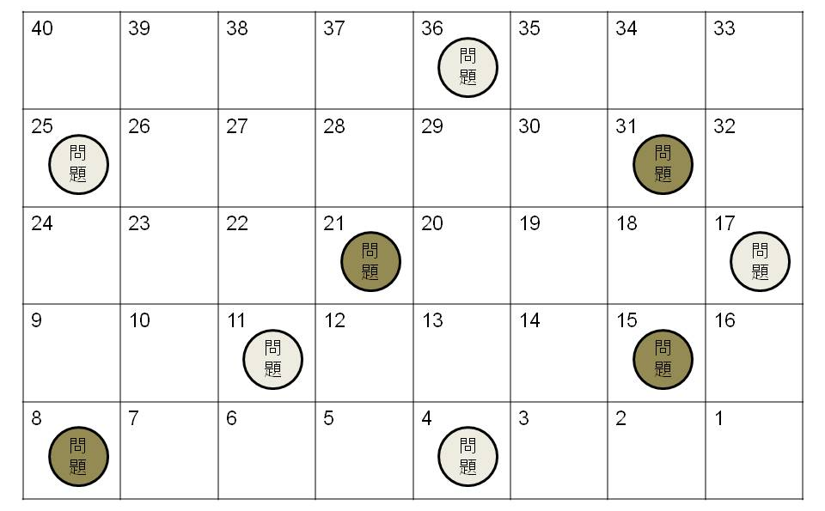
Question
Question
Question
Question
Question
Question
Question
Question
Question

