**Senior Secondary Liberal Studies /**

**Citizenship and Social Development**

**Field Study Design**

|  |  |
| --- | --- |
| **Topic of field study** | Tai Kwun: One-stop Approach for Law and Order |
| **Course-related parts** | **Senior Secondary Liberal Studies**  Module 2: Hong Kong Today  Theme 2: Rule of law and socio-political participation   * In what ways does the rule of law protect rights and promote the observance of responsibilities among Hong Kong residents? |
| **Senior Secondary Citizenship and Social Development**  Theme 1: Hong Kong under “One Country, Two Systems”  Topic: The meaning and implementation of “one country, two systems”  Learning Focus: Significance of rule of law |
| **Objectives** | Through the field study, students are expected to:   * Understand law enforcement, judicial and penal systems in Hong Kong * Understand the implementation situation of human rights and the rule of law in Hong Kong * Master the skills of collecting text and video data at the site, and use them for completing a report * Reflect on the learning experiences gained from field study and become law-abiding good citizens |
| **Duration** | About 1.5 hours |
| **Advice for use** | * Before the field study, introduce the poster and electronic presentation of “Human Rights and the Rule of Law” developed by the Education Bureau. Details of the materials can be found at the relevant part of the web page below:   https://www.edb.gov.hk/tc/curriculum-development/kla/pshe/basic-law-education/cble\_wallcharts/index.html (Chinese version is currently available)   * The entire field study design includes preparation, tasks, as well as extended learning and reflection afterwards. The teacher can make appropriate revisions or adjustments according to the school-based situation. * Before the field study, students should read the reference materials (pages 3-5 below) for preparation. During the field study, they should take photos and extract information from exhibition panels as required. After the field study, they should compile the data and complete the worksheet, before submitting it to the teacher for review. * Tai Kwun is an important architectural heritage in Hong Kong. Teachers may design a separate worksheet related to the field study and ask students to enquire issues related to heritage conservation as well as revitalisation. If such arrangement is made, the duration of the field study should be extended as appropriate. * Teachers may visit the official website of Tai Kwun (https://www.taikwun.hk/en/), and refer to the *Teacher’s resource handbook* (https://www.taikwun.hk/assets/uploads/programme\_files/jc3PSTDKLQ.pdf)compiled by the organisation for teachers. By doing so, teachers can get acquainted with the history of Tai Kwun, its relationship with the development of Hong Kong, and how the revitalisation of Tai Kwun demonstrates a good practice for Hong Kong’s heritage conservation and management. As such, teachers can guide students to enhance their understanding of Tai Kwun in class or during the field study. |

**Field Study Worksheet**[[1]](#footnote-1)

**Name of activity: “Tai Kwun: One-stop Approach for Law and Order”**

**(I) Objectives**

Visit Tai Kwun to learn about the historical development of law enforcement, judicial and penal systems in Hong Kong. Enhance students’ understanding of the rule of law and human rights.

**(II) Pre-study preparation**

Before the field study, students need to review the relevant contents learnt in classroom learning and read information about the site and make proper preparation. Refer to the three reading materials below for details:

**Reading Material 1**: The basic meaning of rule of law

|  |
| --- |
| * Everyone is equal before the law * Must act in accordance with the law, and both residents and the government must obey the law * The power of the government and all officials all come from what are stipulated in the law and the law under the decisions of independent courts * The courts must be independent of the executive authorities * All people, unless with legal basis, must not act to result in statutory presumption fault, or hinder the freedoms of other people * Rule of law is based on respecting laws and the rights of other people * Objectives to be achieved :   + Safeguarding the peace and stability of the society   + Protecting the safety and property of individuals |

Sources:

Extracted from the EDB seminar titled “《基本法》教育研討會系列（二）基本法下的法治和司法獨立” with Honorable Mr Justice Patrick CHAN Siu-oi as the speaker (5 June 2014) and the website of the Department of Justice

**Reading Material 2**: The speech delivered by the Chief Justice of the Court of Final Appeal at the Ceremonial Opening of the Legal Year 2020 (Extract)

|  |
| --- |
| The administration of justice - or the practical way in which justice is dispensed in the day-to-day work of the courts - has as its central characteristic the requirement of a fair trial. Trials involve serious consequences…In a criminal case setting, the fairness of a trial means fairness to all sides, both to the prosecution and to the defence… A fair trial does not mean that there must be a conviction or an acquittal depending on one's personal or political viewpoint: the outcome of a criminal trial depends on the evidence that is presented to the court, whether it is sufficiently cogent and whether the burden of proof (proof beyond a reasonable doubt) has been discharged by the prosecution…  　　The judicial oath, which Article 104 of the Basic Law states must be taken, requires all judges to uphold the Basic Law and conscientiously, dutifully, in full accordance with the law, honestly and with integrity, safeguard the law and administer justice without fear or favour, self‑interest or deceit. There can be no compromising of these fundamentals…  The task of the courts is to resolve legal disputes in accordance with the law. Everyone is subject to the law, no one is above it. The guarantee and requirement of equality ensures that everyone, high or low, public body or citizen, are subject to the law and answerable to it. There are no exceptions. |

Source:

Extracted from the speech delivered by the Chief Justice of the Court of Final Appeal at the Ceremonial Opening of the Legal Year 2020 (13 January 2020). Press Release of The Government of The Hong Kong Special Administrative Region. https://www.info.gov.hk/gia/general/202001/13/P2020011300622.htm

**Reading Material 3**: *Heritage in Tai Kwun* (downloadable from the following website; to be read before the study)

https://www.taikwun.hk/assets/filemanager/userfiles/Webpages/Heritage/Tai\_Kwun\_Heritage\_Main\_Leaflet\_Digital\_2020.pdf

**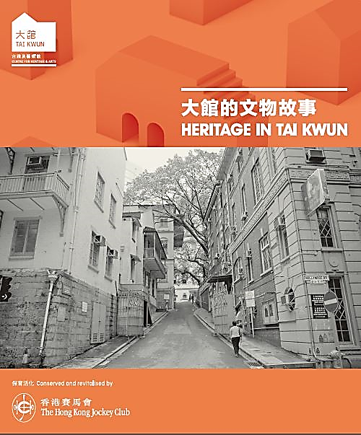**

**(III) Field study tasks** (two in total)

**Task 1**: Get a general idea about the entire Tai Kwun compound and locations of the field study sites

* After entering Tai Kwun, look for the venue map and understand the layout of the entire compound, so as to easily locate the study sites within the venue.
* Go to the Visitor Centre for a tour of the exhibition hall named “Main Heritage Gallery”, in order to learn about the history of the compound. Pay special attention to the details of the three groups of buildings below. Summarise their information in the following boxes:

| **Name of building** | **Purpose of building** |
| --- | --- |
| **Central Police Station** | **Pre-World War II, the site housed police department ranging from headquarters to district level; and, right up to decommissioning in 2004. Central Police Station still serves as Hong Kong Island Regional Headquarters, Central District Headquarters and Central Divisional Police Station.**  **Suspects were usually charged in the Central Police Station Charge Room (renamed the Report Room in 1961), and kept in the holding cells at the back of the room until their trial.** |
| **Central Magistracy** | **Situated alongside the Central Police Station and Victoria Prison, Central Magistracy connected the two institutions literally and figuratively. Defendants were brought from the police station to a cell beneath the courtroom for their trial.**  **From the 1960s onwards, Central Magistracy dealt mostly with preliminary hearings. More serious cases were then transferred to other courts.** |
| **Victoria Prison** | **In the early days, when defendants were found guilty, they were incarcerated in Victoria Gaol (also known as Victoria Prison). After Stanley Prison opened in 1937, Victoria Prison was increasingly used for remand prisoners. From the 1950s to 1970s, it served as a Reception Centre for the Prisons Department, with both remand and convicted prisoners processed here. In the 1980s, the Immigration Department set up Victoria Immigration Centre here to handle cases related to illegal immigrants and other immigration offenders.** |

* Read the introductory leaflet (bottom left picture) in the exhibition area. Pay attention to the content and the six field study sites (A to F in the bottom right picture) as a route guide for Task 2.

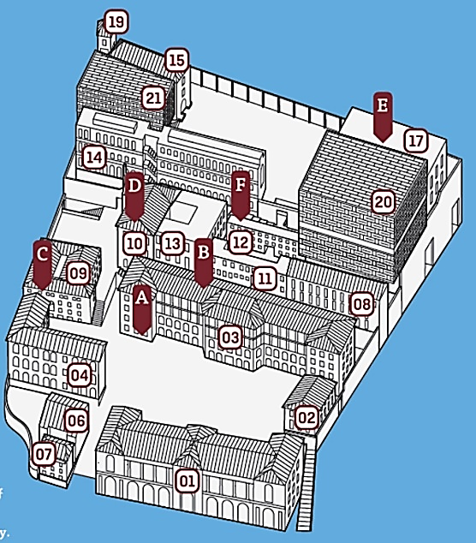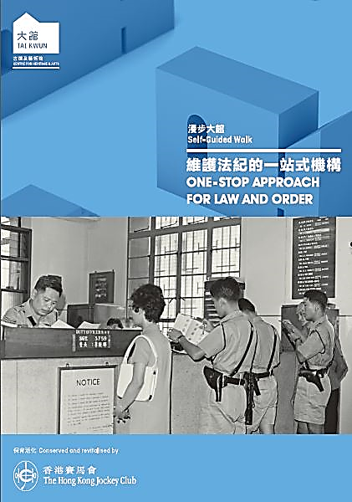

　A. Charge Room B. Holding Cell

C. Courtroom No. 1

D. Entrance to Victoria Prison

　E. Fingerprinting Office F. Cells

**Task 2**: Visit the facilities of law enforcement (A & B), justice (C) and corrections (D, E & F), in line with the six procedures of “**Arrest → Detention → Trial → Sentence → Prisoner Admission →Imprisonment**”.

**Site A**: Charge Room (Block 3, G/F, Barrack Block) → Arrest

* Answer the following questions based on the leaflet and findings at the site.

|  |
| --- |
| Explain the general procedure for arresting suspects.  **After an arrest is made, suspects are escorted to the Central Police Station Charge Room. Here the police carry out a series of procedures – confirming identity, interviewing the suspects and ultimately deciding whether and what to charge.** |
| What factors were considered for the location of the charge room?  **The Charge Room was located in this spot for the simple reason that it was a convenient place for the public to report crimes. The location also provided a strategic view of people and vehicles coming up Pottinger Ramp into the compound.**  **In the early days, the Duty Officer’s desk was elevated to accentuate the authority and standing of the police.** |
| What was the charge room called after the renaming in 1961? What is the previous charge room used for after the revitalisation?  **The charge room was renamed “Report Room” in 1961. After revitalisation, the location of the charge room was used as a restaurant.** |
| Among the exhibition items, find a photo showing the new name of the charge room. Take a photo and paste it in the box below.  **(Photo for reference)** |

**Site B**: Holding Cell (Behind Block 3, Barrack Lane) → Detention

* There is an exhibition panel at the previous holding cells. Find the panel. Take a photo and paste it in the box below. Answer the following questions based on the leaflet and findings at the site.

|  |
| --- |
| Photo of the previous holding cells on the exhibition panel **(photo for reference)**  C:\Users\USER\Desktop\大館\IMG_6431.JPGC:\Users\kcli\Desktop\憲法和基本法教材\通識教育組開發的教材\工作紙二__參觀\參考材料\大館相關相片\IMG_6430.JPG |
| Use of the holding cells and the adjacent interview room  **After being charged, suspects are kept in the holding cells before they are released, or charged and tried at Central Magistracy. The interview room next to the cells is used for interrogation.** |

**Site C**: Courtroom No.1 (Block 9, G/F, Central Magistracy) → Trial

* First go to the basement of the magistracy. Take a photo of the basement holding room and the underground passage through which suspects were brought from the basement holding room to the courtroom upstairs. Paste the photo in the box below.

|  |
| --- |
| **Basement holding room** |
| **(Photo for reference)**  C:\Users\USER\Desktop\大館\IMG_6438.JPG |
| **Underground passage from the holding cells in the basement to the courtroom upstairs** |
| **(Photo for reference)**  C:\Users\USER\Desktop\大館\IMG_6436.JPG |

* Browse the information on the exhibition panel about the Central Magistracy in the basement. Select two cases and briefly explain how they illustrated the rule of law.

|  |  |
| --- | --- |
| **Case**  **A** | **Details**:  **In 1974, the Hong Kong Independent Commission Against Corruption (ICAC) was established. Peter Fitzroy Godber, a former Chief Superintendent of the Royal Hong Kong Police Force, was extradited back to Hong Kong for trial for corruption.** |
| **The rule of law embodied**:  **Everyone is equal before the law. And everyone, high or low, public body or citizen, are subject to the law and answerable to it.** |
| **Case**  **B** | **Details**:  **In 1977, Magistrate Barrington-Jones sentences a court interpreter to three years in prison for accepting bribes.**  **“It is a very sad day when a court in Hong Kong finds itself faced with overwhelming evidence pointing to the guilt of person who is a court officer… but the court, no matter the circumstances, must fearlessly continue to do its duty.”** |
| **The rule of law embodied**:  **According to the Judicial Oath taken by judges sworn in, judges should safeguard the law and administer justice without fear or favour, self-interest or deceit.** |

* A video clip about a simulated case trial at the Central Magistracy is looped in Courtroom No. 1 (see the photo below; the video clip lasts about 8 minutes, with bilingual narration in Chinese and English). Please answer the questions in the box after watching the video clip.

|  |  |
| --- | --- |
| C:\Users\USER\Desktop\大館\IMG_6460.JPG | C:\Users\USER\Desktop\大館\IMG_6450.JPG |
| Question: Based on the materials you read before the visit and to the best of your knowledge, which parts of the trial in the video clip conform to the rule of law.   * **The court is a place where justice is administered. No one can escape legal responsibilities with any excuse.** * **Everyone is equal before the law.** * **The law protects personal safety and property.** * **The presumption of innocence.** * **Interpretation service is provided for parties to the litigation who do not understand English so that they can get a fair trial.** * **The outcome of a trial depends on the evidence that is presented to the court, whether it is sufficiently cogent and whether the burden of proof (proof beyond a reasonable doubt) has been discharged by the prosecution.** | |

**Site D**: Entrance to Victoria Prison (Block 10, G/F) → Sentence

* Complete the following table based on the information obtained from the field study.

|  |
| --- |
| Take a photo of the main entrance of Victoria Prison and paste it in the box below **(photo for reference)**  C:\Users\USER\Desktop\大館\IMG_6468.JPG |
| When was the building at the main entrance of Victoria Prison completed? What other purposes did the building serve at that time?  **Presumably completed in 1862, the building was used as the main entrance of Victoria Prison, as well as the Prison Superintendent’s Quarters. Therefore, it was also called the Superintendent’s House. It was one of the earliest buildings constructed in the compound.** |
| What was the building converted into later? What traces of the conversion can still be seen?  **The main entrance of the building was once enclosed as an indoor space and converted into a prison chapel.**  **Nowadays, the remaining chapel murals can still be seen on the walls on both sides of the entrance.** |

**Site E**: Fingerprinting Office (Block 17, F Hall, G/F) → Prisoner Admission

* In the 1970s, what were the ten admission procedures prisoners needed to complete for identification before they became inmates?

|  |  |
| --- | --- |
| Step 1: **Confirming your identity** | Step 6: **Collecting your daily necessities** |
| Step 2: **You are now going to be searched** | Step 7: **Being fingerprinted** |
| Step 3: **Your prisoner number is your identity** | Step 8: **Having a mug shot taken** |
| Step 4: **No personal property allowed** | Step 9: **Keeping hold of your identity card** |
| Step 5: **Undergoing a body check** | Step 10: **Following the rules** |

**Site F**: Cells (Block 12, B Hall, G/F) → Imprisonment

* Take two photos of the holding cell and paste them in the box below. Briefly share your feelings about the cell environment.

|  |
| --- |
| Holding cell photo 1 **(photo for reference)**  C:\Users\kcli\Desktop\IMG_6661.jpg |
| Holding cell photo 2 **(photo for reference)**  C:\Users\USER\Desktop\大館\IMG_6493.JPG |

|  |
| --- |
| My feelings about the cell environment  **Answer based on findings during the field study** |

* The photo on the left below was taken from an introduction video about the cell. Collect information in the field study and answer the question.

**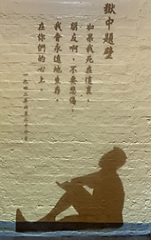**

|  |
| --- |
| Question: Which modern Chinese writer does the silhouette represent? Why was he arrested and held in Victoria Prison?  **The silhouette below shows Dai Wangshu, a famous poet in modern China. After Japan invaded China in 1937, Dai moved to Hong Kong and became Chief Editor of a supplement in Ta Kung Pao. A year later, he became Chief Editor of a supplement in Sing Tao Daily News. In late 1941, the Japanese authorities in Hong Kong arrested and jailed Dai. It was widely thought that this was due to the anti-Japanese newspaper articles he had written.** |

* The photo below was taken from the exhibition panel in one of the holding cells. Try to explain why such rules were necessary from the perspective of prison management and security.

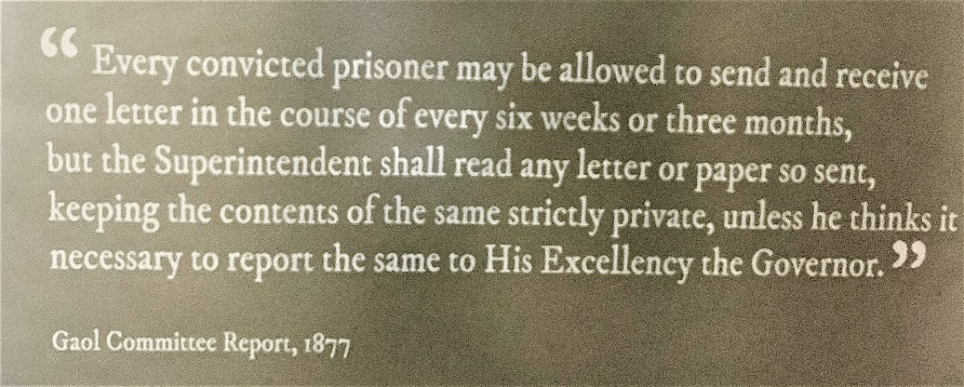

|  |
| --- |
| **The prison needed to formulate clear rules to facilitate management. It was also intended to prevent inmates from disclosing security information about the prison or even potential illegal actions to outsiders via letters. Therefore the Superintendent had the right to read the contents of letters and report to the Governor when anything suspicious was noticed.**  **On the other hand, prisoners were sentenced to jail for breaking the law. Their rights were restricted as a result. They could only communicate with the outside world to a limited extent in accordance with prison regulations. The contents of their letters could only be kept private when there was nothing suspicious.** |

**(IV) Extended learning and reflection after the field study**

|  |
| --- |
| * William Caine was the first Chief Magistrate of Hong Kong (1841) and the founder of the Hong Kong Police Force (1844). The Caine Road and Caine Lane at the Mid-Levels in Hong Kong Island were named after his last name.   In the mid-19th century, the systems in Hong Kong were still incomplete. William Caine held multiple positions, and he even briefly served as the acting Governor of Hong Kong (May-September 1859). Such acting arrangement, with judicial and executive powers being held in one body, is no longer adopted in Hong Kong. Which dimension of the rule of law do you think is involved in that regard? How is it important for Hong Kong?  **The rule of law emphasises judicial independence. Hong Kong does not adopt an arrangement where judicial and executive powers are held in one body. It is precisely based on such consideration.**  **According to the rule of law, judicial operation should be independent of the executive and the legislative branches, so as to form a check and balance to ensure that the judiciary is free from the influence of all other factors, including the influence of government and the legislature. In that way, judges can perform their duties fairly in accordance with the law. They will not be deterred just because their rulings may go against the government’s will. Since Hong Kong has an independent judicial system, even the government cannot be above the law. This helps Hong Kong move towards a fairer society.** |
| * Which provisions of the Basic Law can reflect the rule of law you have mentioned in the previous question? Write down those provisions in the table.  |  |  | | --- | --- | | **Dimension of the rule of law mentioned in the previous question** | **Relevant provisions of the Basic Law** | | **Judicial independence** | **Article 2: The National People's Congress authorizes the Hong Kong Special Administrative Region to exercise a high degree of autonomy and enjoy executive, legislative and independent judicial power, including that of final adjudication, in accordance with the provisions of this Law.** | | **Article 19: The Hong Kong Special Administrative Region shall be vested with independent judicial power, including that of final adjudication.** | | **Article 85: The courts of the Hong Kong Special Administrative Region shall exercise judicial power independently, free from any interference. Members of the judiciary shall be immune from legal action in the performance of their judicial functions** |  * The following table lists three items related to the dimension of the rule of law. Try to find the relevant provisions in the Basic Law and write them down in the table.  |  |  | | --- | --- | | **Item relating to the dimension of the rule of law** | **Relevant provisions of the Basic Law** | | Everyone is equal before the law. | **Article 25: All Hong Kong residents shall be equal before the law.** | | The law restricts the power of the government | **Article 64:** **The Government of the Hong Kong Special Administrative Region must abide by the law and be accountable to the Legislative Council of the Region: it shall implement laws passed by the Council and already in force; it shall present regular policy addresses to the Council; it shall answer questions raised by members of the Council; and it shall obtain approval from the Council for taxation and public expenditure.** | | Fair and open trial and the right to appeal | **Article 87:** **In criminal or civil proceedings in the Hong Kong Special Administrative Region, the principles previously applied in Hong Kong and the rights previously enjoyed by parties to proceedings shall be maintained.**  **Anyone who is lawfully arrested shall have the right to a fair trial by the judicial organs without delay and shall be presumed innocent until convicted by the judicial organs.** |  * Compared with what you knew before the field study, how has this activity enhanced your understanding of law enforcement, judicial and penal systems in Hong Kong? Explain.   **Answer based on findings during the field study**   * To what extent has this activity enhanced your law-abiding awareness? Explain.   **Answer based on findings during the field study** |

- End -

1. The photos in the Worksheet were taken by the resource developer in Tai Kwun. And parts of the answer keys are taken from the exhibition panels and leaflet of the organisation. [↑](#footnote-ref-1)