**Citizenship and Social Development**

**Theme 1: Hong Kong under “One country, two systems” [For Students’ Use]**

|  |
| --- |
| **Prior knowledge**  In basic education, students should have already acquired the following learning experiences:   * a brief understanding of the three unequal treaties and their background * a preliminary understanding of the process of Hong Kong’s return to China * a general understanding of the constitutional basis, enactment and promulgation of the Basic Law |

**Theme: Historical background of “One country, two systems” and the process of Hong Kong’s return to China**

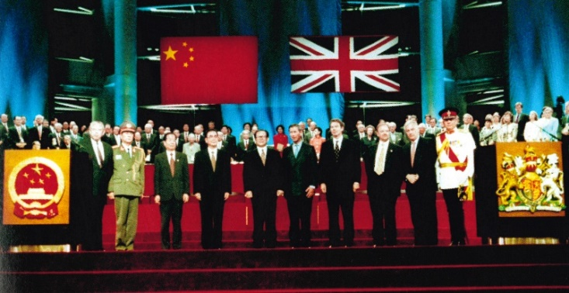

**(I) Historical background of the three unequal treaties and the origin of the Basic Law**

Hong Kong has been part of the territory of China since ancient times, it was occupied by Britain after the Opium War in 1840. On 19 December 1984, the Chinese and British Governments signed the Joint Declaration on the Question of Hong Kong, affirming that the Government of the People’s Republic of China will resume the exercise of sovereignty over Hong Kong with effect from 1 July 1997, thus fulfilling the long-cherished common aspiration of the Chinese people for the recovery of Hong Kong.

|  |
| --- |
| The first stage of the Sino-British negotiations covered the period from September 1982, when Margaret Thatcher, the British prime minister visited China, to June 1983. The second stage lasted from July 1983 to September 1984, when the Sino-British Joint Declaration was initialled.  China has never recognised the three unequal treaties and had always held sovereignty over Hong Kong. This is very clear and there is no room for discussion. |

The Sino-British Joint Declaration of 19 December 1984

The Sino-British Joint Declaration consists of a main document and three annexes.

Focuses of the main document include:

1. The Government of the People's Republic of China declares that to recover the Hong Kong area (including Hong Kong Island, Kowloon and the New Territories, hereinafter referred to as Hong Kong) is the common aspiration of the entire Chinese people, and that it has decided to resume the exercise of sovereignty over Hong Kong with effect from 1 July 1997.
2. The Government of the United Kingdom declares that it will restore Hong Kong to the People’s Republic of China with effect from 1 July 1997.
3. The Government of the People’s Republic of China declares that there are 12 basic policies of the People's Republic of China regarding Hong Kong.

**Source A: Video clip of “緣來《基本法》”**

Source A: video clip of **緣來《基本法》**

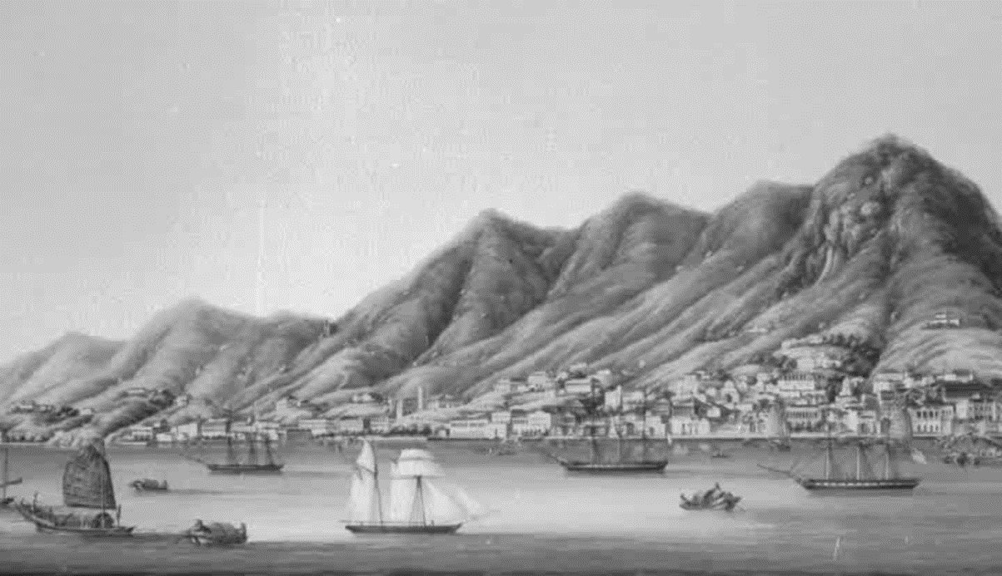

The video is retrieved from the Basic Law video teaching resource package for secondary schools in 2015. The video can be browsed on the “Self-learning web page for students” on the Citizenship and Social Development Web-based Resource Platform.

The video lasts for about 7 minutes.

1. Based on the video clip in Source A, insert the items **at appropriate places of the timeline** in chronological order.

**The Qing government and Britain signed the three unequal treaties in the 19th century**



1. **Name of treaty**

**6.** **Event**

**7.** **Name of treaty**

**8. Year**

**2. Year**

**5. Year 年**

**Now**

**The Qing Dysnasty**

**4.** **Name of treaty**

**9. Event**

**3. Event**

**Year**

**1842**

**1898**

**1860**

**The Treaty of Nanking**

**The Convention for the Extension of Hong Kong Territory**

**The Convention of Peking**《北京條約》

**Name of treaty**

**China was in the danger of the scramble for concessions of the Great Powers. Britain forced the Qing government into leasing the lands north of Boundary Street as well as the New Territories, for a term of 99 years, until 30 June 1997.**

**The Qing government was defeated by the allied British and French forces. It was forced to cede the part of Kowloon Peninsula south of the Boundary Street to Britain.**

**The Qing government was defeated in the Opium War and was forced to cede Hong Kong Island to Britain.**

**Event**

**(II) A chronology of Hong Kong’s return to China**

|  |
| --- |
| **Restoration of the lawful rights of the People’s Republic of China in the United Nations in 1971**  United Nations General Assembly Resolution 2758 (XXVI)  　　Resolution: To restore all its rights to the People’s Republic of China and to recognise the representatives of its Government as the only legitimate representatives of China to the United Nations, and to expel forthwith the representatives of Chiang Kai-shek from the place which they unlawfully occupy at the United Nations and in all the organisations related to it. |

|  |
| --- |
| **Removal of Hong Kong and Macau from the list of Non-Self-Governing Territories in 1972**  The questions of Hong Kong and Macau were the results of a series of unequal treaties imposed on China by the imperialists. Hong Kong and Macau were part of Chinese territory occupied by the British and Portuguese authorities. The resolutions of the questions of Hong Kong and Macau were entirely within the sovereignty of China and do not fall under the scope of colonies.  On 2 November 1972, the UN General Assembly approved the resolution report of the Special Committee on the Decolonisation, removing Hong Kong and Macau from the list of Non-Self-Governing Territories. |

2. Based on the video clip in Source A, insert the items **at appropriate places of the timeline** in chronological order.

**A chronology of Hong Kong’s return to China**

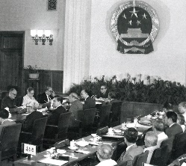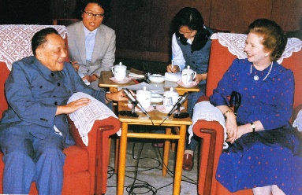

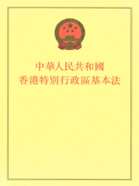

**12. Details of the event**

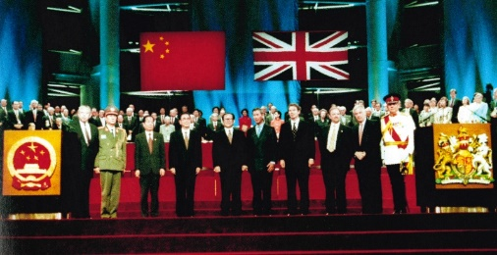

**11.** **Name of the event**

**2. Details of the event details**

**9. Details of the event**

**8.** **Name of the event**

1. **Name of the event**

**10. Date**

**1997**

**1984**

**Now**

**1982**

**1990**

**1985**

**13. Date**

**3.** **Name of the event**

**5. Date**

**15. Details of the event**

**14.** **Name of the event**

**6.** **Name of the event**

**4. Details of the event**

**16. Details of the event**

**17. Details of the event**

**7. Details of the event**

The previous capitalist system and way of life shall remain unchanged for 50 years in the HKSAR, with progress in the political system under the principle of a high degree of autonomy.

British Prime Minister Margaret Thatcher visited China to negotiate with the Chinese leaders on the future of Hong Kong.

The NPC adopted the Basic Law together with the designs for the flag and emblem of the HKSAR.

The Basic Law was promulgated by Order No. 26 of the President of the People’s Republic of China, effective as of 1 July 1997.

Article 31 of the Constitution provides a legal basis for the formulation of the Basic Law. The Constitution of the PRC and the Basic Law form the constitutional basis of the HKSAR. The Constitution is the ultimate basis for the Basic Law.

The state may establish special administrative regions when necessary. The systems instituted in special administrative regions shall, in light of specific circumstances, be prescribed by laws enacted by the National People's Congress.

The key points of the main document are:

* To recover the Hong Kong area (including Hong Kong Island, Kowloon and the New Territories) is the common aspiration of the entire Chinese people, and the Government of the People's Republic of China has decided to resume the exercise of sovereignty over Hong Kong with effect from 1 July 1997.
* There are 12 basic policies regarding Hong Kong.

**Details**

**of the events**

After the Handover

* The Chief Executive is elected by the Election Committee (“Selection Committee” for the first Chief Executive), and appointed by the Central People’s Government.
* The Legislative Councils includes members returned by the Election Committee, those returned by functional constituencies, and those by geographical constituencies through direct elections.
* The Court of Final Appeal of the HKSAR is responsible for the final adjudication.

The NPC set up the Basic Law Drafting Committee and authorised its Hong Kong members to form a broadly representative Basic Law Consultative Committee.

Before the Handover

* The Governor was appointed by the British Royal Family
* In 1985, the first indirect election of Legislative Council members (less than 45%)

The Judicial Committee of the Privy Council in London was responsible for the final adjudication.

j



**Name**

**of the events**

Establishment of the HKSAR and implementation of the Basic Law

Signing of the Sino-British Joint Declaration

The NPC’s adoption of the Basic Law

The NPC adopted the Constitution of 1982, with an additional of Article 31

Negotiations over the future of Hong Kong

Drafting of the Basic Law

**Date**

_________

From 4 April 1990

From 1 July 1997

19 December 1984

References:

* *The Constitution and the Basic Law Education* webpage. Hong Kong: Education Bureau.
* “*活學趣論‧基本說法 ─《基本法》視像教材套2015*”. Hong Kong: Education Bureau.
* Personal, Social and Humanities Education Section of Curriculum Development Institute (2017). *Resource Package on “The Integrative Use of Generic Skills”*. Hong Kong: Education Bureau.