Field Study Worksheet

Name of activity: “Tai Kwun: One-stop Approach for Law and Order”

(I) Objectives

Visit Tai Kwun to learn about the historical development of law enforcement, judicial and penal systems in Hong Kong. Enhance students’ understanding of the rule of law and human rights.

(II) Pre-study preparation

Before the field study, students need to review the relevant contents learnt in classroom learning and read information about the site and make proper preparation. Refer to the three reading materials below for details:

Reading Material 1: The basic meaning of rule of law

- Everyone is equal before the law
- Must act in accordance with the law, and both residents and the government must obey the law
- The power of the government and all officials all come from what are stipulated in the law and the law under the decisions of independent courts
- The courts must be independent of the executive authorities
- All people, unless with legal basis, must not act to result in statutory presumption fault, or hinder the freedoms of other people
- Rule of law is based on respecting laws and the rights of other people
- Objectives to be achieved :
  - Safeguarding the peace and stability of the society
  - Protecting the safety and property of individuals
Sources:
Extracted from the EDB seminar titled “《基本法》教育研討會系列（二）基本法下的法治和司法獨立” with Honorable Mr Justice Patrick CHAN Siu-oi as the speaker (5 June 2014) and the website of the Department of Justice

Reading Material 2: The speech delivered by the Chief Justice of the Court of Final Appeal at the Ceremonial Opening of the Legal Year 2020 (Extract)

The administration of justice - or the practical way in which justice is dispensed in the day-to-day work of the courts - has as its central characteristic the requirement of a fair trial. Trials involve serious consequences…In a criminal case setting, the fairness of a trial means fairness to all sides, both to the prosecution and to the defence… A fair trial does not mean that there must be a conviction or an acquittal depending on one's personal or political viewpoint: the outcome of a criminal trial depends on the evidence that is presented to the court, whether it is sufficiently cogent and whether the burden of proof (proof beyond a reasonable doubt) has been discharged by the prosecution…

The judicial oath, which Article 104 of the Basic Law states must be taken, requires all judges to uphold the Basic Law and conscientiously, dutifully, in full accordance with the law, honestly and with integrity, safeguard the law and administer justice without fear or favour, self‑interest or deceit. There can be no compromising of these fundamentals…

The task of the courts is to resolve legal disputes in accordance with the law. Everyone is subject to the law, no one is above it. The guarantee and requirement of equality ensures that everyone, high or low, public body or citizen, are subject to the law and answerable to it. There are no exceptions.

Source:
Extracted from the speech delivered by the Chief Justice of the Court of Final Appeal at the Ceremonial Opening of the Legal Year 2020 (13 January 2020). Press Release of The Government of The Hong Kong Special Administrative Region. https://www.info.gov.hk/gia/general/202001/13/P2020011300622.htm

Reading Material 3: Heritage in Tai Kwun (downloadable from the following website; to be read before the study)
https://www.taikwun.hk/assets/filemanager/userfiles/Webpages/Heritage/Tai_Kwun_Heritage_Main_Leaflet_Digital_2020.pdf
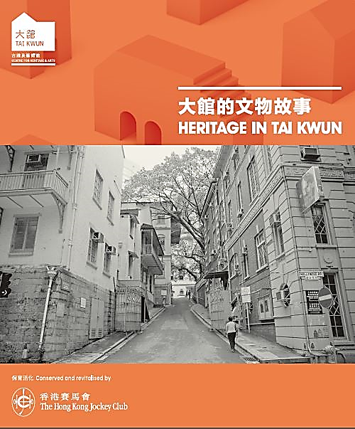

(III) Field study tasks (two in total)

Task 1: Get a general idea about the entire Tai Kwun compound and locations of the field study sites

- After entering Tai Kwun, look for the venue map and understand the layout of the entire compound, so as to easily locate the study sites within the venue.

- Go to the Visitor Centre for a tour of the exhibition hall named “Main Heritage Gallery”, in order to learn about the history of the compound. Pay special attention to the details of the three groups of buildings below. Summarise their information in the following boxes:

Name of building | Purpose of building
Central Police Station
Central Magistracy
Victoria Prison

- Read the introductory leaflet (bottom left picture) in the exhibition area. Pay attention to the content and the six field study sites (A to F in the bottom right picture) as a route guide for Task 2.
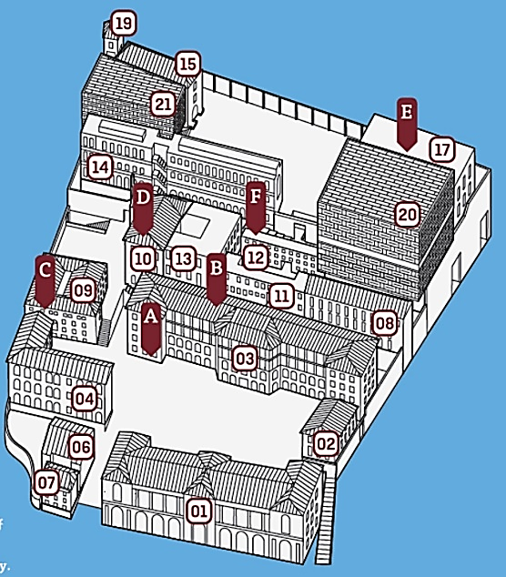
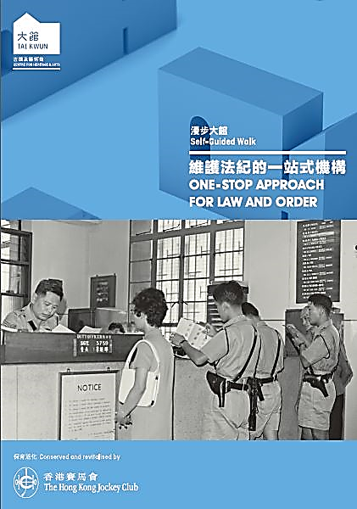

A. Charge Room B. Holding Cell
C. Courtroom No. 1
D. Entrance to Victoria Prison
E. Fingerprinting Office F. Cells

Task 2: Visit the facilities of law enforcement (A & B), justice (C) and corrections (D, E & F), in line with the six procedures of “Arrest → Detention → Trial → Sentence → Prisoner Admission →Imprisonment”.

Site A: Charge Room (Block 3, G/F, Barrack Block) → Arrest

- Answer the following questions based on the leaflet and findings at the site.

Explain the general procedure for arresting suspects.

What factors were considered for the location of the charge room?

What was the charge room called after the renaming in 1961? What is the previous charge room used for after the revitalisation?

Among the exhibition items, find a photo showing the new name of the charge room. Take a photo and paste it in the box below.

Site B: Holding Cell (Behind Block 3, Barrack Lane) → Detention

- There is an exhibition panel at the previous holding cells. Find the panel. Take a photo and paste it in the box below. Answer the following questions based on the leaflet and findings at the site.

Photo of the previous holding cells on the exhibition panel

Use of the holding cells and the adjacent interview room

Site C: Courtroom No.1 (Block 9, G/F, Central Magistracy) → Trial

- First go to the basement of the magistracy. Take a photo of the basement holding room and the underground passage through which suspects were brought from the basement holding room to the courtroom upstairs. Paste the photo in the box below.

Basement holding room
Underground passage from the holding cells in the basement to the courtroom upstairs

- Browse the information on the exhibition panel about the Central Magistracy in the basement. Select two cases and briefly explain how they illustrated the rule of law.

Case  A | Details:
 | The rule of law embodied:
Case  B | Details:
 | The rule of law embodied:

- A video clip about a simulated case trial at the Central Magistracy is looped in Courtroom No. 1 (see the photo below; the video clip lasts about 8 minutes, with bilingual narration in Chinese and English). Please answer the questions in the box after watching the video clip.

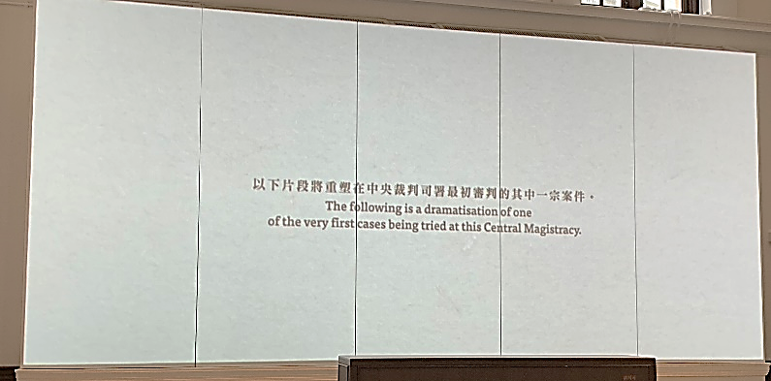 | 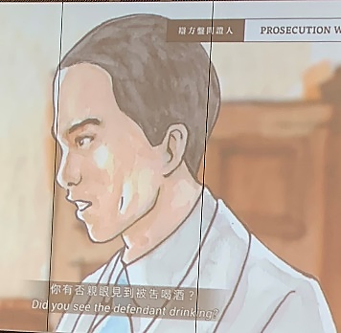
Question: Based on the materials you read before the visit and to the best of your knowledge, which parts of the trial in the video clip conform to the rule of law.

Site D: Entrance to Victoria Prison (Block 10, G/F) → Sentence

- Complete the following table based on the information obtained from the field study.

Take a photo of the main entrance of Victoria Prison and paste it in the box below

When was the building at the main entrance of Victoria Prison completed? What other purposes did the building serve at that time?

What was the building converted into later? What traces of the conversion can still be seen?

Site E: Fingerprinting Office (Block 17, F Hall, G/F) → Prisoner Admission

- In the 1970s, what were the ten admission procedures prisoners needed to complete for identification before they became inmates?

Step 1: | Step 6:
Step 2: | Step 7:
Step 3: | Step 8:
Step 4: | Step 9:
Step 5: | Step 10:

Site F: Cells (Block 12, B Hall, G/F) → Imprisonment

- Take two photos of the holding cell and paste them in the box below. Briefly share your feelings about the cell environment.

Holding cell photo 1

Holding cell photo 2

My feelings about the cell environment

- The photo on the left below was taken from an introduction video about the cell. Collect information in the field study and answer the question.
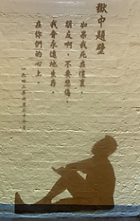
Question: Which modern Chinese writer does the silhouette represent? Why was he arrested and held in Victoria Prison?

- The photo below was taken from the exhibition panel in one of the holding cells. Try to explain why such rules were necessary from the perspective of prison management and security.

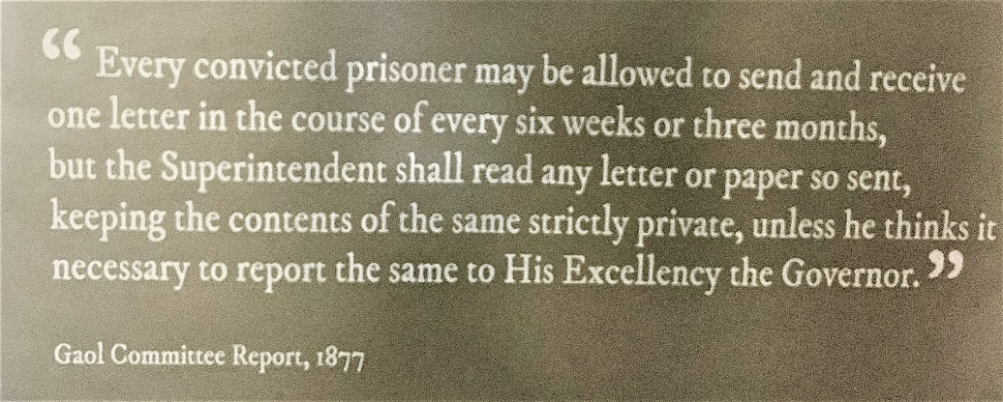

(IV) Extended learning and reflection after the field study

- William Caine was the first Chief Magistrate of Hong Kong (1841) and the founder of the Hong Kong Police Force (1844). The Caine Road and Caine Lane at the Mid-Levels in Hong Kong Island were named after his last name.
In the mid-19th century, the systems in Hong Kong were still incomplete. William Caine held multiple positions, and he even briefly served as the acting Governor of Hong Kong (May-September 1859). Such acting arrangement, with judicial and executive powers being held in one body, is no longer adopted in Hong Kong. Which dimension of the rule of law do you think is involved in that regard? How is it important for Hong Kong?

- Which provisions of the Basic Law can reflect the rule of law you have mentioned in the previous question? Write down those provisions in the table.

Dimension of the rule of law mentioned in the previous question | Relevant provisions of the Basic Law
 | Article :
 | Article :
 | Article :

- The following table lists three items related to the dimension of the rule of law. Try to find the relevant provisions in the Basic Law and write them down in the table.

Item relating to the dimension of the rule of law | Relevant provisions of the Basic Law
Everyone is equal before the law. | Article :
The law restricts the power of the government | Article :
Fair and open trial and the right to appeal | Article :

- Compared with what you knew before the field study, how has this activity enhanced your understanding of law enforcement, judicial and penal systems in Hong Kong? Explain.

- To what extent has this activity enhanced your law-abiding awareness? Explain.

- End -

